FIELD ARTILLERY CANNON CREWMAN
MOS 13B SKILL LEVEL 4
DUTIES OF THE SAFETY OFFICER/NCO
SUBCOURSE FA9010
US Army Field Artillery School
Fort Sill, Oklahoma
Three Credit Hours

GENERAL
This subcourse is designed to train the skills necessary for performing range safety card, safety diagram, safety diagram dogleg, safety diagram corrections, and safety T. This subcourse is presented in one lesson corresponding to a terminal objective supporting the following soldier manual task:
TASK NO: 01-2660.00-8025
TASK: Compute all required safety data.
CONDITIONS: Given a GFT, GST, and within a classroom environment, compute target safety data IAW FM 6-50.
STANDARDS: To compute target safety data without error.

TABLE OF CONTENTS
Lesson: Duties of the Safety Officer/NCO
Introduction
Developing the Safety Card
Duties of Safety Personnel
Range Safety Card
Safety Diagram
Safety Diagram Dogleg
Safety Diagram Corrections
Safety Aids
Safety T
Shell White Phosphorus
Shell WP Actual Weight
Shell Smoke
Shell Illuminating
High-Angle Fire
Quadrant Elevation for High-Angle Fire
Summary
EXAMINATION
ADMINISTRATIVE INSTRUCTIONS
Subcourse content. This subcourse contains one lesson related to computing the target safety data. An introduction presents an overall view of the subject. The lesson then explains how to perform each task as it pertains to the duties of the safety officer/NCO.
Supplementary requirements.The following subcourses should be completed before taking this subcourse:
a. FA9003, Determine Basic Low Angle Firing Data with a GFT.
b. FA9002, Determine Site, Angle of Site, VI, and Vertical Angles with a GST.
c. FA9006, High-Angle.
d. FA9007, Illumination Firing Data.
Prerequisites are based solely within the correspondence course curricula. Therefore, enrollees who have acquired this included knowledge from other sources may not need to complete listed subcourses. If unable to complete this subcourse because of lack of prerequisite knowledge, request the prerequisite subcourse(s) from:

DUTIES OF THE SAFETY OFFICER/NCO
OBJECTIVE
Upon completion of this subcourse, you will be able to prepare a range safety card.
REFERENCES
This lesson is based on FM 6-50 and other materials approved for US Army field artillery instruction; however, development and progress render this material continually subject to change. Therefore, base your examination answers on material presented in this text rather than on individual or unit experience.
1. INTRODUCTION. Safety is probably more critical in the Field Artillery than in any other branch of the Army. Although safety is a command responsibility, safety must always be on the minds of everyone in the military. Under peacetime conditions, a safety officer/NCO may be detailed to help the battery executive officer (XO) in this responsibility. The safety officer/NCO has two principal duties: (1) to ensure the weapons are laid and loaded so the rounds land in the prescribed area; (2) to ensure all safety precautions are observed at the firing point. Any decision made by the safety officer/NCO concerning safety can be overruled only by the officer in charge of firing. The duties of the safety officer/NCO involve skills and knowledge acquired under the headings of firing battery, cannon material, and fire direction. Therefore, these subjects are not taught in this subcourse, but you are reminded, when necessary, of the source of information and how to use it.
2. DEVELOPING THE SAFETY CARD. The range safety card is furnished to the officer in charge (OIC) of firing. He issues it to the safety officer/NCO a day or two before the service practice firing exercise is scheduled. The range safety card is valid only when signed by the range safety officer.
3. DUTIES OF SAFETY PERSONNEL. During service practice, designated personnel have specific responsibilities for safety. These safety officers/NCOs and their prescribed duties are as follows:
a. Officer in charge of firing - The OIC of firing is the battery commander or the safety-certified direct representative and is responsible for all aspects of safety during the firing exercise.
b. Battery executive officer - The XO is responsible for the safety practices of the firing battery.
c. Assistant executive officer/fire direction officer - The assistant executive officer’s/fire direction officer’s (AXO/FDO) primary responsibilities are to compute the safety diagram from the safety data and to update the safety diagram after registrations. The AXO/FDO ensures all firing data are within safety limits before transmission to the firing sections.
d. Chief of firing section - The chief of firing section is responsible for firing the weapon, ensuring safe practices are employed at or near the weapon, and verifying that the proper firing data are applied to the weapon and that the proper charge, fuze, and projectile are fired.
e. Range control officer - The range control officer (RCO) provides the OIC of firing with a range safety card.
f. Battery safety officer/NCO - The battery safety officer/ NCO is responsible for safety checks to ensure that only authorized ammunition is fired, rounds land within the designated impact areas, and no unsafe practices take place at or near the weapon(s).
NOTE: Regardless of rank, anyone observing an unsafe condition or act related to firing should immediately announce CHECK FIRING and report the incident to responsible personnel.

PRACTICE EXERCISES:
Complete the following exercises by circling T for true or F for false, circling the letter preceding the correct answer, or filling in the blanks, as appropriate. Be sure to complete the practice exercises as they appear. They are “building blocks and will help you complete the rest of the subcourse successfully. The answers follow the last exercise and are separated by rows of slashes (////). If any of your answers are incorrect, restudy the appropriate part of the subcourse before you continue.
1. The ______ ________ _________is responsible for the safety practices of the firing battery.
2. The _____ _____ _________ensures that the proper firing data are applied to the weapon.
3. The _____ _________ ________furnishes the officer in charge of firing with the range safety card.
4. The ______ ________ _________ensures that only authorized ammunition is fired and that rounds land within the designated impact areas.
5. The _____ ____ ____ _____is responsible for all aspects of safety during the firing exercise.
6. The ___________computes the safety diagram and updates the safety diagram after registrations.
7. If an unsafe condition or act related to firing is observed, announce ____________________ _______________, and report the incident to responsible personnel.
/ / / / / / / / / / / / / / / / / / / / / / / / / / / / / / / / / / / / / / / / / / / / / / / / / / / / / / / / / /
ANSWERS:
1. battery executive officer
2. chief of firing section
3. range control officer
4. battery safety officer/NCO
5. officer in charge of firing
6. AXO/FDO
7. CHECK FIRING
/ / / / / / / / / / / / / / / / / / / / / / / / / / / / / / / / / / / / / / / / / / / / / / / / / / / / / / / / / /

4. RANGE SAFETY CARD.
a. The range safety card is developed by the range officer and contains the following information:
(1) Unit and date.
(2) Firing point and area.
(3) Weapon.
(4) Ammunition.
(5) Type of fire.
(6) Direction limits.
(7) Range limits.
(8) Minimum and maximum charges.
(9) Special instructions.
b. The range safety card is furnished to the officer in charge of firing, who issues it to the safety officer/NCO a day or two before the service practice firing exercise is scheduled. The range safety card is valid only when signed by the range safety officer.

PRACTICE EXERCISES:
Refer to Figure 1, and complete the following statements by circling the correct letter.
8. Laterally, the impact area is bounded by-
a. azimuth 3700 and 6210.
b. azimuth 5800 and 3700.
c. azimuth 5880 and 6210.
d. azimuth 5880 and 4700.

9. This safety card is valid f or- a, towed 203-mm (8-inch) howitzer.
b. self-propelled 105-mm howitzer.
c. towed 105-mm howitzer.
d. self-propelled 155-mm howitzer.

10. This card authorizes the use of- a, low-angle fire.
b. illuminating fire.
c. high-angle fire.
d. suppression fire.

11. This card authorizes the use of-
a. illuminating.
b. smoke.
c. high explosive.
d. ICM.
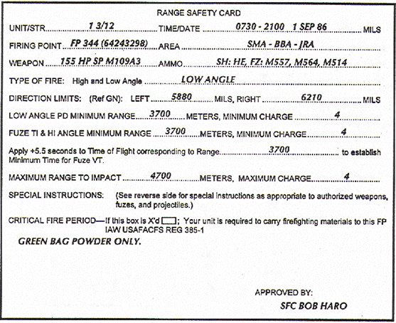

The following data have been determined:
Azimuth of lay 6000
Battery altitude 390
Maximum altitude at minimum range 420
Minimum altitude at maximum range 330
Common deflection 3200

Figure 1. Range safety card

/ / / / / / / / / / / / / / / / / / / / / / / / / / / / / / / / / / / / / / / / / / / / / / / / / / / / / / / / / /
ANSWERS:
8. c.
9.d.
10. a.
11. c.
/ / / / / / / / / / / / / / / / / / / / / / / / / / / / / / / / / / / / / / / / / / / / / / / / / / / / / / / / / /

5. SAFETY DIAGRAM.
a. The safety diagram is a graphical representation of the data on the range safety card and must be constructed before registration. The diagram, shows the lateral and range limits and may be constructed on a card 3 by 5 inches or larger, depending on the amount of data required in the situation. Figure 2 illustrates the information required on the basic safety diagram.

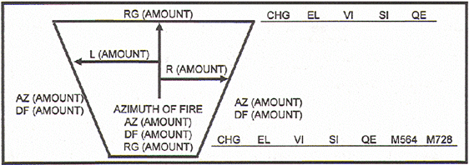
Figure 2. Basic safety diagram
PRACTICE EXERCISE:
You will now start constructing a basic safety diagram. Use a separate sheet of paper to draw your diagram. The procedures will be explained step by step, and you will need to add to your diagram for each succeeding activity.
12. Begin the diagram construction by drawing an arrow representing the azimuth of fire, and assume that the battery is laid on azimuth (az) 6000 and the common deflection (df) is 3200. Label the arrow AZIMUTH OF FIRE and record AZ 6000 and DF 3200 below the arrow. Refer to Figure 2 for your example.
/ / / / / / / / / / / / / / / / / / / / / / / / / / / / / / / / / / / / / / / / / / / / / / / / / / / / / / / / / /
ANSWER:
12. Your sketch should resemble the one below. The entries must be the same.
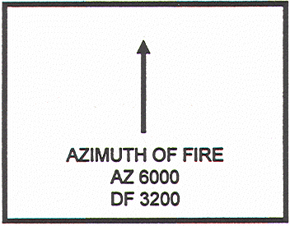
/ / / / / / / / / / / / / / / / / / / / / / / / / / / / / / / / / / / / / / / / / / / / / / / / / / / / / / / / / /

b. To determine the angular measurement from the azimuth of fire to each lateral limit, compute the difference between the azimuth of fire and the azimuth to each lateral limit. For example, if the direction of fire were 1600, the right limit 1900, and the left limit 1400, the sketch would be as shown in Figure 3 below.

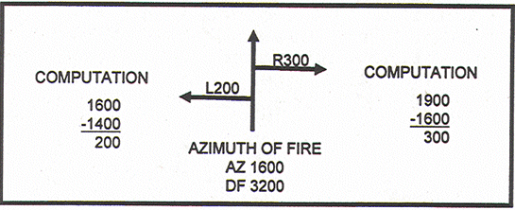
Figure 3. Computation of lateral limits.

PRACTICE EXERCISE:
13. Using the safety range card (Fig 1), draw an arrow from the azimuth of fire arrow to each lateral limit. Record above each arrow the angular measurement with a letter representing the direction (L=Left, R=Right), and show your computations.
/ / / / / / / / / / / / / / / / / / / / / / / / / / / / / / / / / / / / / / / / / / / / / / / / / / / / / / / / / /

ANSWER:
13. Your sketch should resemble the one below.
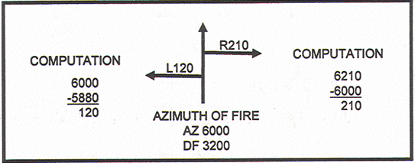

/ / / / / / / / / / / / / / / / / / / / / / / / / / / / / / / / / / / / / / / / / / / / / / / / / / / / / / / / / /
c. To complete the diagram of the impact area, lines representing the lateral limits must be drawn on the diagram. The azimuth of each line is recorded along the upper, outer edges of the diagram. The near ends of the lateral limit lines must connect with a line that represents the minimum (mm) range. The far ends of the lateral limit lines must connect with a line that represents the maximum (max) range (rg)

PRACTICE EXERCISE:
14. Draw the lines that represent the lateral limits and the lines that represent the minimum and maximum ranges (Fig 2). Record the azimuth and range on their respective lines using the information from the range card (Fig 1).
/ / / / / / / / / / / / / / / / / / / / / / / / / / / / / / / / / / / / / / / / / / / / / / / / / / / / / / / / / /
ANSWER:
14. Your diagram should resemble the one below.

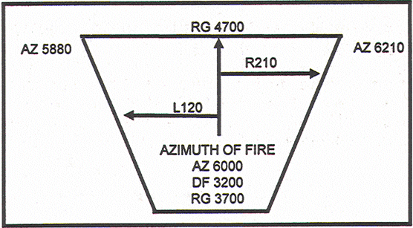

/ / / / / / / / / / / / / / / / / / / / / / / / / / / / / / / / / / / / / / / / / / / / / / / / / / / / / / / / / /

d. To compute the deflection limits, the lateral angular measurements must be applied to the common deflection (3200) As an example: Assume the deflection limits are 200 mils left and right of the azimuth of fire, and the common deflection is 3200. By applying the LARS (left, add; right, subtract) rule, the deflection limits are determined to be right 3000 (3200 - 200) and left 3400 (3200 + 200)
/ / / / / / / / / / / / / / / / / / / / / / / / / / / / / / / / / / / / / / / / / / / / / / / / / / / / / / / / / /

PRACTICE EXERCISE:
15. Using the information already entered on your diagram, compute the deflections and record the deflection limits below the respective azimuth limits (left and right).

ANSWER: / / / / / / / / / / / / / / / / / / / / / / / / / / / / / / / / / / / / / / / / / / / / / / / / / / / / / / / / / /

15. Your diagram should resemble the one below.

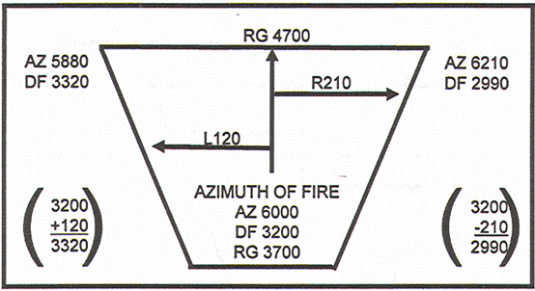

/ / / / / / / / / / / / / / / / / / / / / / / / / / / / / / / / / / / / / / / / / / / / / / / / / / / / / / / / / /
e. To determine the minimum quadrant elevation (QE) for the minimum range (3,700 meters on your safety card), two factors must be applied--site to the highest altitude along the minimum range and elevation corresponding to the minimum range. The battery altitude is 390 meters. The highest altitude along the minimum range given on your safety card is 420 meters. Therefore, the vertical interval (VI) is +30.

PRACTICE EXERCISE:
16. Using the graphical site table (GST), determine site to the highest altitude at minimum range. If you need assistance in using the GST, refer to subcourse FA 9002.
Complete the following statement:
To the nearest mil and with the proper sign, the site for charge 4GB is _______________.

/ / / / / / / / / / / / / / / / / / / / / / / / / / / / / / / / / / / / / / / / / / / / / / / / / / / / / / / / / /
ANSWER:
16. +11. (Target above guns [TAG] carries a plus sign.)
/ / / / / / / / / / / / / / / / / / / / / / / / / / / / / / / / / / / / / / / / / / / / / / / / / / / / / / / / / /
f. Minimum QE consists of site (si) to the highest altitude plus the elevation (el) corresponding to the minimum range. Elevation can be determined from either the graphical firing table (GFT) or the tabular firing table (TFT), table F, column 2. If you need assistance in using the GFT, refer to subcourse FA 9003.

PRACTICE EXERCISES:
17. Using the GFT, determine the elevation for the minimum range on your safety card; then complete the following statement:
The elevation corresponding to the minimum range for charge 4GB to the nearest mil is _____________________________, and the minimum QE is ___________________mils.
18. Record the minimum range data in a line next to the basic safety diagram. The arrangement and location of these data are shown in Figure 2.
/ / / / / / / / / / / / / / / / / / / / / / / / / / / / / / / / / / / / / / / / / / / / / / / / / / / / / / / / / /
ANSWER:
17. 212, 233 (The GFT elevation is 212. Elevation (212) plus site (+11) equals the minimum QE of 233.)
18. Your diagram should resemble the one below.

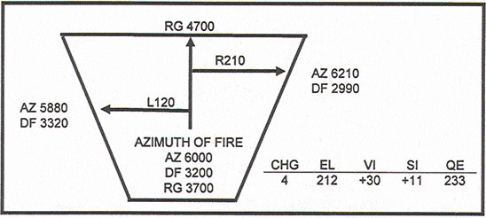

/ / / / / / / / / / / / / / / / / / / / / / / / / / / / / / / / / / / / / / / / / / / / / / / / / / / / / / / / / /
g. The next step is to determine the minimum time (fuze setting [FS] for fuze M564) at the minimum range on the safety card. The minimum time is that fuze setting corresponding to the elevation for the minimum range and is expressed to the nearest tenth (0.1). This time may be determined from either the TFT (table F, column 3) or the GFT.
PRACTICE EXERCISE:
19. Determine the minimum time for fuze M564 from the GFT; then record the data in the appropriate place on the diagram.
/ / / / / / / / / / / / / / / / / / / / / / / / / / / / / / / / / / / / / / / / / / / / / / / / / / / / / / / / / /
ANSWER:
19. 12.9 Your diagram should resemble the one on the next page.

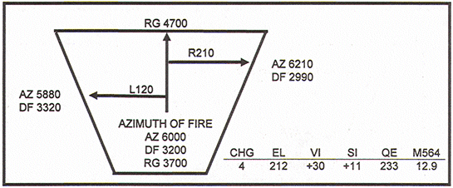

/ / / / / / / / / / / / / / / / / / / / / / / / / / / / / / / / / / / / / / / / / / / / / / / / / / / / / / / / / /
h. To determine the minimum FS for fuze M514 for the minimum range, two factors must be applied--the time of flight (TOF), to the nearest tenth, that corresponds to the elevation at minimum range plus a 5.5-second safety factor. Time of flight is extracted from the TFT, table F, column 7. When the sum of the two numbers is not a whole number, you express the sum as the next higher whole number.
EXAMPLE: 19.8 (TOF) + 5.5 (safety factor) = 25.3, which is expressed as 26.0. To get the TOF, enter table F of the TFT at the minimum range and read across to column 7.
PRACTICE EXERCISE:
20. Extract the TOP from the TFT, compute the minimum fuze setting M5l4, and record the data on your diagram.
/ / / / / / / / / / / / / / / / / / / / / / / / / / / / / / / / / / / / / / / / / / / / / / / / / / / / / / / / / /

ANSWER:
20. 19.0 (TOF from TFT is 12.9 + 5.5 = 18.4, which is expressed as 19.0.). Your diagram should resemble the one below.

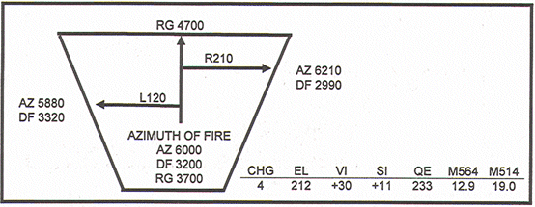

/ / / / / / / / / / / / / / / / / / / / / / / / / / / / / / / / / / / / / / / / / / / / / / / / / / / / / / / / / /
i. To determine the maximum QE for the maximum range (4,700 meters on your safety card), two factors must be applied--site to the lowest altitude along the maximum range and elevation corresponding to the maximum range. The battery altitude is 390 meters, and the lowest altitude along the maximum RG given on the safety card is 330 meters. Therefore, the VI is -60.
PRACTICE EXERCISE:
21. Using the GST, determine the site to the lowest altitude on the maximum range, and complete the following statement.
To the nearest mil and with the proper sign, site for charge 4GB is ________________________.
/ / / / / / / / / / / / / / / / / / / / / / / / / / / / / / / / / / / / / / / / / / / / / / / / / / / / / / / / / /
ANSWER:
21. -14. (Target below guns [TGB] carries a minus sign.)

/ / / / / / / / / / / / / / / / / / / / / / / / / / / / / / / / / / / / / / / / / / / / / / / / / / / / / / / / / /

j. Maximum QE consists of site to the lowest altitude on the maximum RG plus the EL corresponding to the maximum range. Elevation can be determined from either the GFT or the TFT.
k. Maximum range data may be recorded along a line above the upper right corner of the basic safety diagram. The arrangement and location of these data are shown in Figure 4.

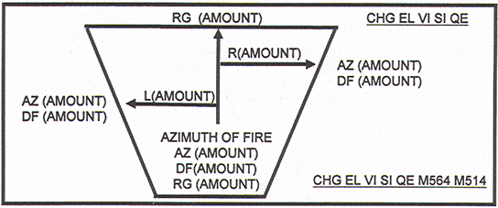

Figure 4. Location of maximum OE.

PRACTICE EXERCISES:
22. Using the GFT, determine the elevation at the maximum range on your safety card; then complete the following statement.
The elevation corresponding to the maximum range for charge 4GB, to the nearest mil, is ___________________, and the maximum QE is ______________________mils.

23. Record the maximum QE on your diagram.
/ / / / / / / / / / / / / / / / / / / / / / / / / / / / / / / / / / / / / / / / / / / / / / / / / / / / / / / / / /
ANSWERS:
22. 282, 268. (The elevation is 282. The elevation [282] plus site [ -14] equals the maximum QE of 268.)
23. Your diagram should resemble the one below.

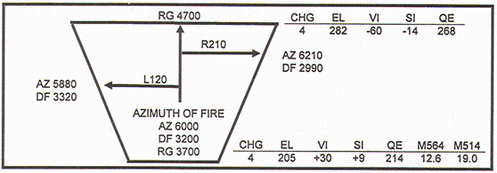

/ / / / / / / / / / / / / / / / / / / / / / / / / / / / / / / / / / / / / / / / / / / / / / / / / / / / / / / / / /
NOTE: These are the steps in construction of the basic safety diagram for charge 4GB. Notice that maximum fuze settings were not computed. Rounds fuzed with M564 or M514 fuzes and fired at the maximum QE will burst on impact even if the FS is too great.
6. SAFETY DIAGRAM DOGLEG. The safety card sometimes describes a section of the impact area that causes the safety diagram to have an offset called a dogleg. The offset area (dogleg) is indicated by azimuth and also by range. Figure 5 is an example of a partially completed safety diagram containing a dogleg.

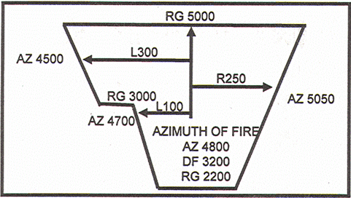

Fig 5. Safety diagram with dogleg.

PRACTICE EXERCISE;
24. Notice in Figure 5, the minimum range is 2200 to the right and 3000 to the left. Using data from Figure 6, construct a basic safety diagram containing only azimuth and range (similar to Fig 5). Use azimuth of lay 0740 and common deflection 3200.

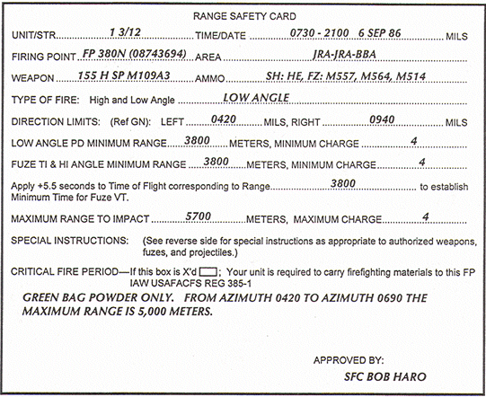

The following data have been determined:
Azimuth of lay 0740
Battery altitude 360
Max altitude at mm range 380
Common deflection 3200
Min altitude at intermediate range 310
Min altitude at max range 310

Figure 6. Completed range card for exercise 24.
/ / / / / / / / / / / / / / / / / / / / / / / / / / / / / / / / / / / / / / / / / / / / / / / / / / / / / / / / / /

ANSWER:
24. Your diagram should resemble the one below.
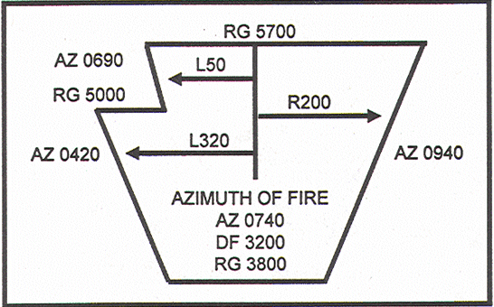

/ / / / / / / / / / / / / / / / / / / / / / / / / / / / / / / / / / / / / / / / / / / / / / / / / / / / / / / / / /
PRACTICE EXERCISE:
25. Using the data from Figure 7, construct the entire safety diagram.

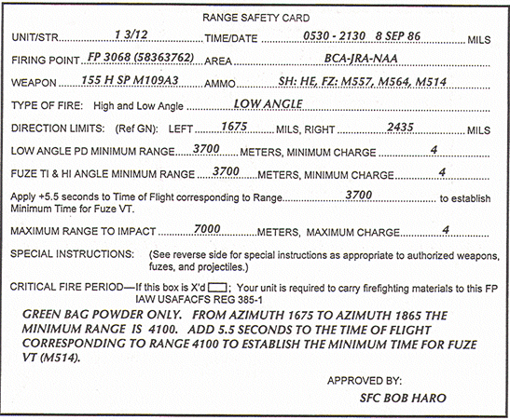

The following data have been determined:
Azimuth of lay 2050
Battery altitude 339
Max altitude at max range 377
Min altitude at max range 368
Max altitude at intermediate range 341
Min altitude at intermediate range 327
Max altitude at mm range 324
Min altitude at max range 320
Common deflection 3200

Figure 7. Comp]eted range card for exercise 25.
/ / / / / / / / / / / / / / / / / / / / / / / / / / / / / / / / / / / / / / / / / / / / / / / / / / / / / / / / / /

ANSWER:
25. Your diagram should resemble the one below.

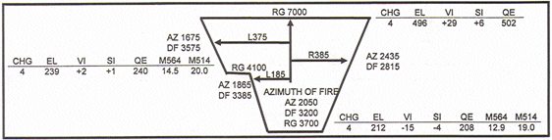

/ / / / / / / / / / / / / / / / / / / / / / / / / / / / / / / / / / / / / / / / / / / / / / / / / / / / / / / / / /

/ / / / / / / / / / / / / / / / / / / / / / / / / / / / / / / / / / / / / / / / / / / / / / / / / / / / / / / / / /
7. SAFETY DIAGRAM CORRECTIONS. Upon completion of a registration, the safety officer/NCO ensures that the deflection correction and GFT setting are received. The basic diagram can then reflect the changes that give added assurance that rounds will impact or explode in the designated impact area. All deflection limits are modified by applying the total deflection correction to each limit using the LARS rule.

PRACTICE EXERCISE:
26. Assume that the safety officer/NCO receives the following information: GFT A: CHARGE 4GB, LOT WS, RANGE 4100, ELEVATION 245, TIME 15.3 TOTAL DEFLECTION CORRECTION L4.
Using the data from the safety diagram in Figure 8, correct the deflection limits on your diagram.
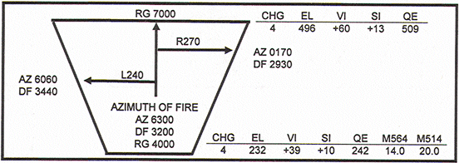

Figure 8. Basic diagram for corrections.
/ / / / / / / / / / / / / / / / / / / / / / / / / / / / / / / / / / / / / / / / / / / / / / / / / / / / / / / / / /
ANSWER:
26. Your diagram should resemble the one below.

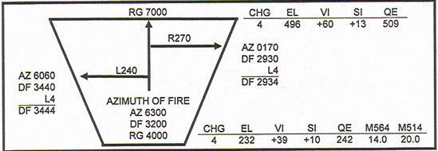

/ / / / / / / / / / / / / / / / / / / / / / / / / / / / / / / / / / / / / / / / / / / / / / / / / / / / / / / / / /
To determine corrections for minimum and maximum QEs and fuze settings, place the GFT setting on the GFT. To determine TOF to be used in the computation of minimum time for variable time (VT) fuze, use the adjusted elevation determined at minimum range as the entry into the TFT. Enter column 2 of table F. If the adjusted elevation is not listed, enter the TFT at the next higher listed elevation and check for TOF in column 7. The +5.5 second safety factor must be added to the TOF and the TOF expressed to the next higher whole second.
PRACTICE EXERCISE:
27. Using the GFT A setting in practice exercise 26 and using site for minimum range as +10 and for maximum range as +13, determine the corrected data on your diagram.
/ / / / / / / / / / / / / / / / / / / / / / / / / / / / / / / / / / / / / / / / / / / / / / / / / / / / / / / / / /
ANSWERS:
27. If your answers are within 1 mil of ours, consider them correct.
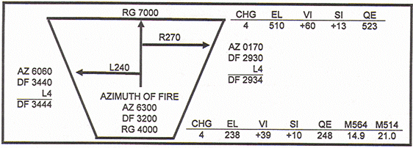

/ / / / / / / / / / / / / / / / / / / / / / / / / / / / / / / / / / / / / / / / / / / / / / / / / / / / / / / / / /
8. SAFETY AIDS. Safety stakes for towed weapons or safety tapes for the howitzers are aids used by the safety officer/NCO in checking the lateral limits. Also, some units require the construction of a safety stake diagram.
a. Safety stakes. To emplace safety stakes, set the deflection limit on the close-in aiming point. Center the bubbles. This action aligns the tube of the piece on the deflection limit. Depress the tube and, by sighting through it, align the safety stake along the outside edge of the bore. Be sure to emplace the stake exactly as you have aligned it, approximately 10 feet in front of the tube.
b. Safety tapes. To emplace tapes on the howitzer, place an index tape on the movable portion of the hull. Then traverse the weapon to the left and right limits and, at each limit, place a piece of tape on the lower hull in alignment with the index. Using the same method, place tapes on the tube and on the front of the upper hull to indicate elevation limits. By standing to the left rear of the weapon and glancing along the tube relative to the position of the tape, you can see when the tube approaches the lateral limit. Refer to Figure 9.

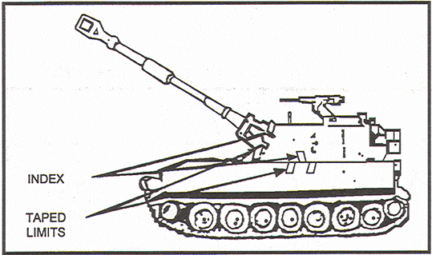
Figure 9. Safety tape

c. Safety stake diagram. This diagram contains the direction of fire, the common deflection to the aiming point, the angular measurement from the direction of fire to each limit, and the deflection to each limit. The deflection limits are determined by applying the angular measurements to the common deflection using the LARS rule.

PRACTICE EXERCISES:
28. Study the safety stake diagram in Figure 10, and complete the diagram by recording the right and left deflection limits.
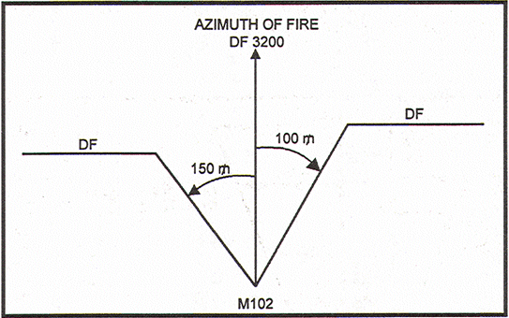
Figure 10. Safety stake diagram for exercise 28
/ / / / / / / / / / / / / / / / / / / / / / / / / / / / / / / / / / / / / / / / / / / / / / / / / / / / / / / / / /

ANSWERS:
28. Your diagram should resemble the one below.
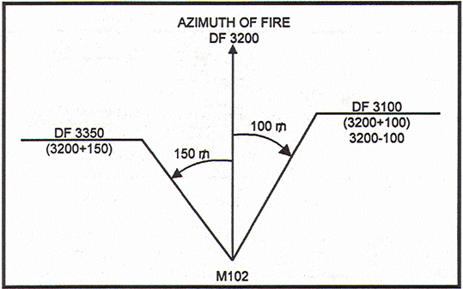

/ / / / / / / / / / / / / / / / / / / / / / / / / / / / / / / / / / / / / / / / / / / / / / / / / / / / / / / / / /
9. SAFETY T. Safety data extracted from the safety diagram are entered on a 3- by 5-inch card in a format known as the safety T. The safety T contains only the necessary information to ensure that fire commands transmitted to the howitzer are safe. The maximum quadrant, minimum quadrant, and minimum time depend on the deflection to be fired. Therefore, to construct a safety T, start with the deflection limits. Figure 11 shows a low-angle safety diagram and an example of the necessary information recorded as a safety T.
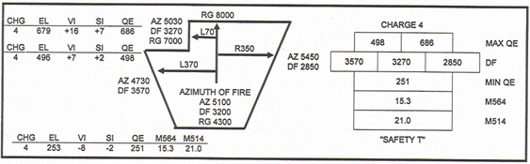
Figure 11. Safety diagram and safety T.

PRACTICE EXERCISE:
Study the safety diagram in Figure 12, and start the construction of a safety T with the deflection limits. Notice that the deflection limits are 3510, 3310, and 2790.

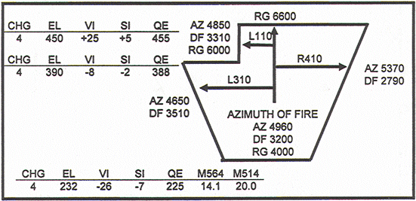

Figure 12. safety diagram for exercise 29.

From the left deflection limit (3510) to the right deflection limit (2790) there are two maximum QEs. At the bottom of the diagram, there is only one set of data.
29. Complete the safety T and remember to put the appropriate charge above the maximum QEs.
/ / / / / / / / / / / / / / / / / / / / / / / / / / / / / / / / / / / / / / / / / / / / / / / / / / / / / / / / / /
ANSWER:
29. Your safety T should resemble the one below.

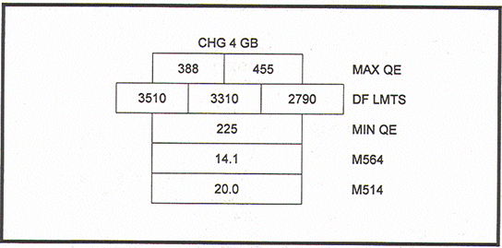

/ / / / / / / / / / / / / / / / / / / / / / / / / / / / / / / / / / / / / / / / / / / / / / / / / / / / / / / / / /
10. SHELL WHITE PHOSPHORUS. The white phosphorus (WP) round is heavier than the high explosive (HE) round. Therefore, a correction must be applied when the minimum QE for shell WP is being determined.
a. When the actual weight of shell WP is unknown, the procedure for determining minimum QE for shell WP is to add 300 meters (m) to the minimum range stated on the range safety card for HE quick (Q) fuze. This correction compensates for this variance. The remainder of the calculations for minimum QE, maximum QE, and deflection limits are identical to those for shell HE except that fuzes quick and time are the only fuzes considered. Fuze VT is not used with the WP round. The WP round is available for only the 105-mm and 155-mm howitzers.
b. To compute the safety data for shell WP in a step-by-step procedure, we will use the following information:
GIVEN: How M1O9A3, 155-mm, shell WP, fuze M557, M564, chg 4GB
Min rg: 3,800 m
Max rg: 6,200 m
VI at mm rg: -17
VI at max rg: +31
Now work through the steps of the procedure. Each step is followed by its solution.
o STEP 1- Determine the minimum range for minimum QE and fuze setting. (3,800 m)

o STEP 2- Determine the maximum correction for shell WP. Square weight (col 19, TBL F, of the TFT) (3,800 m + 300)
o STEP 3- Determine the WP minimum range (3800 + 120 = 3920) (4 x 29 = 116 120)

o STEP 4- Determine elevation for shell WP, using the adjusted minimum range. (226)

o STEP 5- Determine time (ti) fuze M564 used with shell WP, using the adjusted minimum range. (13.8)
o STEP 6- Determine the minimum QE for shell WP, using elevation at adjusted minimum range and HE site (VI, -17) at range 3,800m. (226 mils [ ] ) (Elevation [226] + HE site [-5] = 221). Do not compute the correction factor at maximum range for shell WP. Compute maximum QE as you would compute for shell HE, fuze Q.
Following is an example of computations for shell WP. Data from the preceding page and above are used.
CHG 4GB
HE RG WP RG EL VI HE SITE SHELL WP MIN QE
3800 3920 226 -17 -5 221
MIN TI 564 RG EL VI SITE SHELL WP MAX QE
13.8 6200 408 +31 +6 414

PRACTICE EXERCISES:
30. Given the following data, fill in the information under the computation headings, and then check your answers with ours.
How M109A3, 155-mm, shell WP, fz M557, M564, chg 4GB
Min rg: 4,200 m
Max rg: 6,500 m
VI at min rg: +34
VI at max rg: -20
HE RG WP RG EL VI HE SITE SHELL WP MIN QE
______
MTN TI 564 RG EL VI SITE SHELL WP MAX QE

/ / / / / / / / / / / / / / / / / / / / / / / / / / / / / / / / / / / / / / / / / / / / / / / / / / / / / / / / / /
ANSWERS:
30. CHG 4GB
HE RG WP RG EL VI HE SITE SHELL WP MIN QE
4200 4320 255 +34 +9 264
MTN TI 564 RG EL VI SITE SHELL WP MAX QE
15.4 6500 438 -20 -4 434
/ / / / / / / / / / / / / / / / / / / / / / / / / / / / / / / / / / / / / / / / / / / / / / / / / / / / / / / / / /
11. SHELL WP ACTUAL WEIGHT. If time and situation permit, it may be desirable to compute safety for WP on the basis of the actual weight of the projectile. The weight of the projectile is usually marked on the projectile in terms of so many squares . (See page ix of the TFT for shell/fuze combinations and mean weights. Columns 18 and 19 in table F of the TFT give range corrections for a decrease or an increase of 1 square projectile weight.)
a. To determine the difference in the square weight of a WP projectile and that of a standard projectile, compare the WP projectile weight with the standard projectile weight of 4 squares. For example, if the weight of a WE projectile is 7 , the square difference would be an increase of 3 . If the range correction for an increase of 1 square in projectile weight is +29 (found in column 19, table F of the TFT), then to achieve a range of 4,200 meters, add 29 meters to that range for each square increase in weight to determine elevation. To determine the range correction, the difference in squares is multiplied by the range correction for an increase of 1 square in projectile weight. The answer is then expressed to the nearest 10 meters. In our example, then, we have an increase of 3 squares, and range corrections for 1 square = +29. Multiply these figures and express to the nearest 10 meters, giving 90 m for WP range correction.

b. To determine WP QE, apply the WP correction to the range given (4,200 m). Compute HE site to the given range, and apply to elevation. Time for the M564 fuze is determined at the corrected range.
PRACTICE EXERCISE:
31. Complete the following computations, assuming a vertical interval of +45.
WP QE__________________________
M564 Setting______________________
NOTE: Remember that time settings are not considered at maximum range.
/ / / / / / / / / / / / / / / / / / / / / / / / / / / / / / / / / / / / / / / / / / / / / / / / / / / / / / / / / /
ANSWERS:
31. WP QE is 263 and M564 setting is 15.3.
/ / / / / / / / / / / / / / / / / / / / / / / / / / / / / / / / / / / / / / / / / / / / / / / / / / / / / / / / / /

12. SHELL SMOKE.
a. Refer to page ix of the TFT. You will notice that for shell smoke (hydrothloroethane [HC]) the weight squares are the same as for HE M107. Therefore, safety data computed for HE are valid for HC smoke (smk). But shell smoke (colored) has a mean weight of 8 squares below the standard weight. Because of the weight difference, a range correction must be applied to the HE range to determine the smoke elevation at minimum and maximum ranges and the fuze setting at minimum range.
b. The procedures are the same as for shell WP except that colored smoke is lighter than HE and requires less elevation to achieve a given range. This means the range correction is a minus. The minimum fuze setting for fuze M565 is the same as for M564 and is determined at the corrected smoke range. For fuzes in the M520A1 family, such as the M501 MT fuze, the correction factor from table K (TFT) for the appropriate charge must be applied to the M564 fuze setting determined at the corrected smoke range. Deflection limits are computed the same as for shell HE. (Study the following example.)

EXAMPLE: Shell smoke, fz M565, M501
Min rg: 2,400 m
Charge: 4GB

Difference in weight of projectiles: decrease 8
Weight of unit correction (column 18, table F) : -18
Range correction (8 x -18) = -144 expressed -140 m
Corrected range (2,400 - (-140) = 2,260 m
Elevation (GFT range 2,260) = 122 m
Site (range 2,400) = -4 m
Min QE= 118 m
Min time for corrected mm range of 2,260 m = 7.5
Min time for fuze M501 (Enter table K, TFT, with a time of 7.5, and
extract the correction factor (+0.4) +0.4
Min time for M501 (7.5 + [+0.41]) = 7.9
NOTE: To determine maximum QE, repeat the procedures used to determined minimum QE.
PRACTICE EXERCISE:
32. Complete the information below by writing your computations under the proper headings. Use the following data taken from the range safety card.
M109A1 charge 4GB
Min rg: 3,700 m
Max rg: 6,200 m
Shell colored smoke fuze M565 and M501
You have determined the following data:
Weight of colored smoke--decrease of 8
VI at min rg- -+15
VI at max rg- -+10
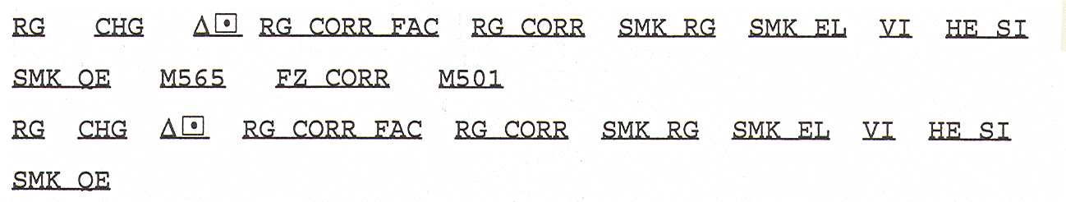
/ / / / / / / / / / / / / / / / / / / / / / / / / / / / / / / / / / / / / / / / / / / / / / / / / / / / / / / / / /

ANSWER:
32.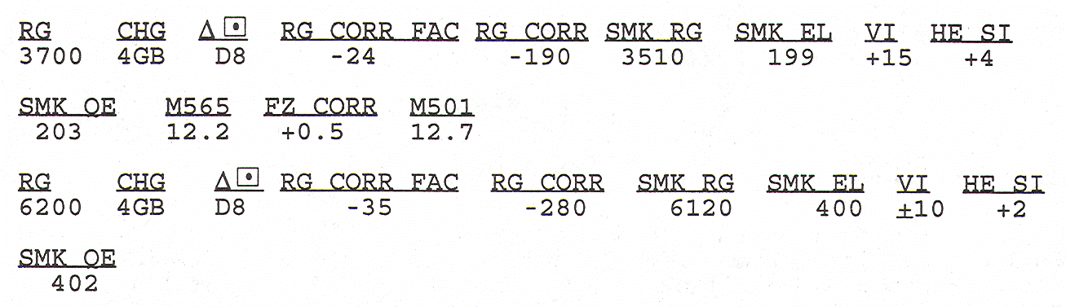

/ / / / / / / / / / / / / / / / / / / / / / / / / / / / / / / / / / / / / / / / / / / / / / / / / / / / / / / / / /
13. SHELL ILLUMINATING. The basic safety diagram for shell illuminating is the same as for shell HE. Whenever possible, the illuminating GFT should be used when computing the minimum and maximum QEs. Refer to your illuminating GFT, charge 3GB. Keep in mind that when computing safety, we are interested in the impact of the projectile on the ground rather than a height of burst. At the top of the illuminating GFT, there is a scale for range in meters; and directly below that is the elevation to impact (ETI) in mils.
a. Determining minimum QE. To determine the minimum QE, read the minimum elevation on the ETI scale. The site for shell HE added to the ETI results in the minimum QE. The M564 fuze setting corresponds to the elevation determined to be valid for shell illuminating and can be read from the HE GFT.
EXAMPLE: Given a minimum range of 5,200 meters and a VI of +17, charge 3GB, minimum QE for shell illuminating is 421.
Computations for this example are:
ETI (Illuminating GFT charge 3GB, range 5200) = 416
Site (VI +17 GST) = +5
QE (Elevation 251 + site [+4] ) = 421
b. Determining maximum QE. To determine the maximum QE, read the maximum elevation on the ETI scale. The site for shell HE added to the ETI results in the maximum QE.
PRACTICE EXERCISE:
33. Given a maximum range of 6,500 meters and a vertical interval of +26, the maximum QE for charge 3GB, shell illuminating is _________________
/ / / / / / / / / / / / / / / / / / / / / / / / / / / / / / / / / / / / / / / / / / / / / / / / / / / / / / / / / /
ANSWER
33. 672.
/ / / / / / / / / / / / / / / / / / / / / / / / / / / / / / / / / / / / / / / / / / / / / / / / / / / / / / / / / /
14. HIGH-ANGLE FIRE.
a. The safety diagram for high-angle fire is nearly the same as that for low-angle fire. However, the method of computing safety limits varies because of the characteristics of the high-angle trajectory. The deflection limits are computed in the same way, except the limits for high-angle fire are modified by the large amount of drift. The left deflection limit is moved to the left by the minimum amount of drift for the charges fired within range limits. The right deflection limit is moved to the left by the maximum amount of drift for the charges fired within range limits.
b. To modify the deflection limits for drift, the value of drift (nearest mil) must be determined for each charge at the maximum and minimum safety card ranges. Compare the drift values for all charges at maximum range, and select the smaller value to modify the left deflection limit. Compare the drift values for all charges at the minimum range, and select the greater value to modify the right deflection limit. Select the drift values from the GFT, when possible. However, if the range and other data are off the end of the GFT, you must check the TFT to determine drift. Because the TFT in the FA 9000 (Fire Direction Kit) is for chg 4GB only, for some of your computations you will need table F, column 8, chg 3GB (Fig 14). If the data are not listed in the TFT either, drift is the value corresponding to the last listed range in the appropriate direction, rounded to the nearest mil.
Study the example given in Figure 12.
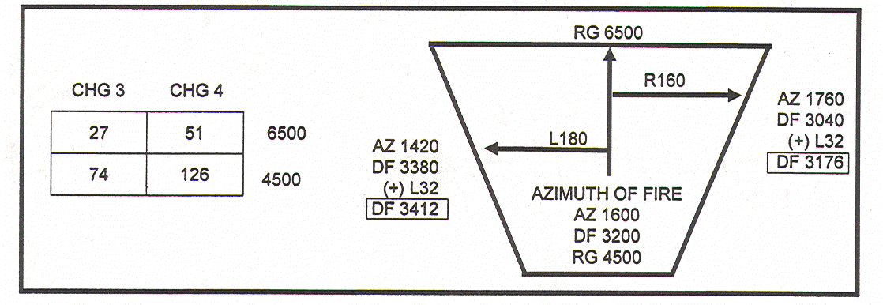
Figure 13. Drift to Deflection.

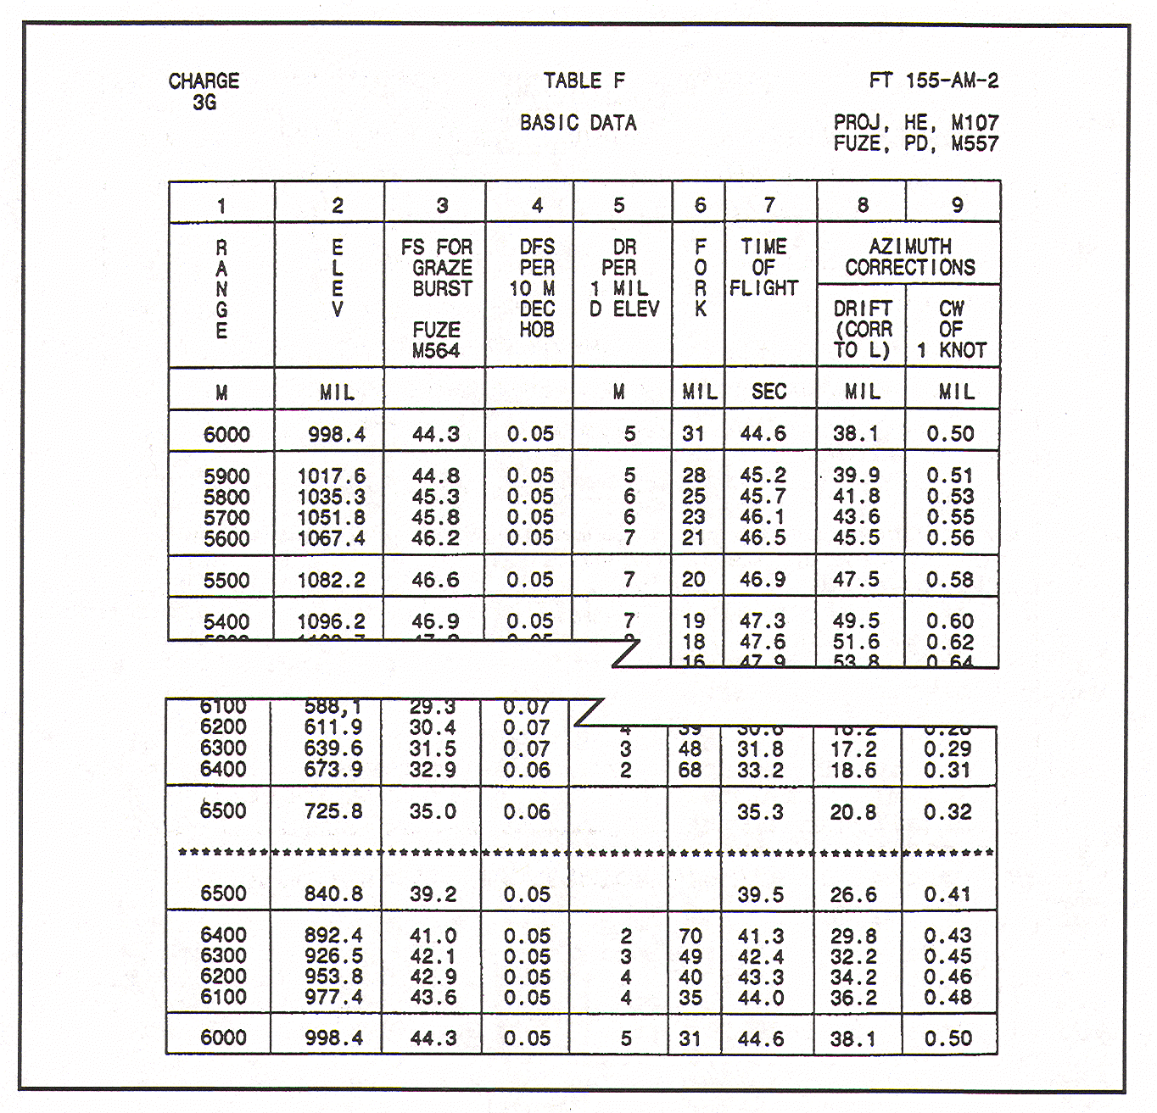
Figure 14. TFT chg 3GB basic data .

PRACTICE EXERCISE:
34. Using data from Figure 15, construct the impact limits (range and lateral) of the basic safety diagram. The battery is laid on azimuth 1950, and the common deflection is 3200. Use the GFT for drift, if possible. Otherwise, use the TFT chg 3GB (Fig 14), or the TFT for chg 4GB that is included in your FA 9000 (Fire Direction Kit)

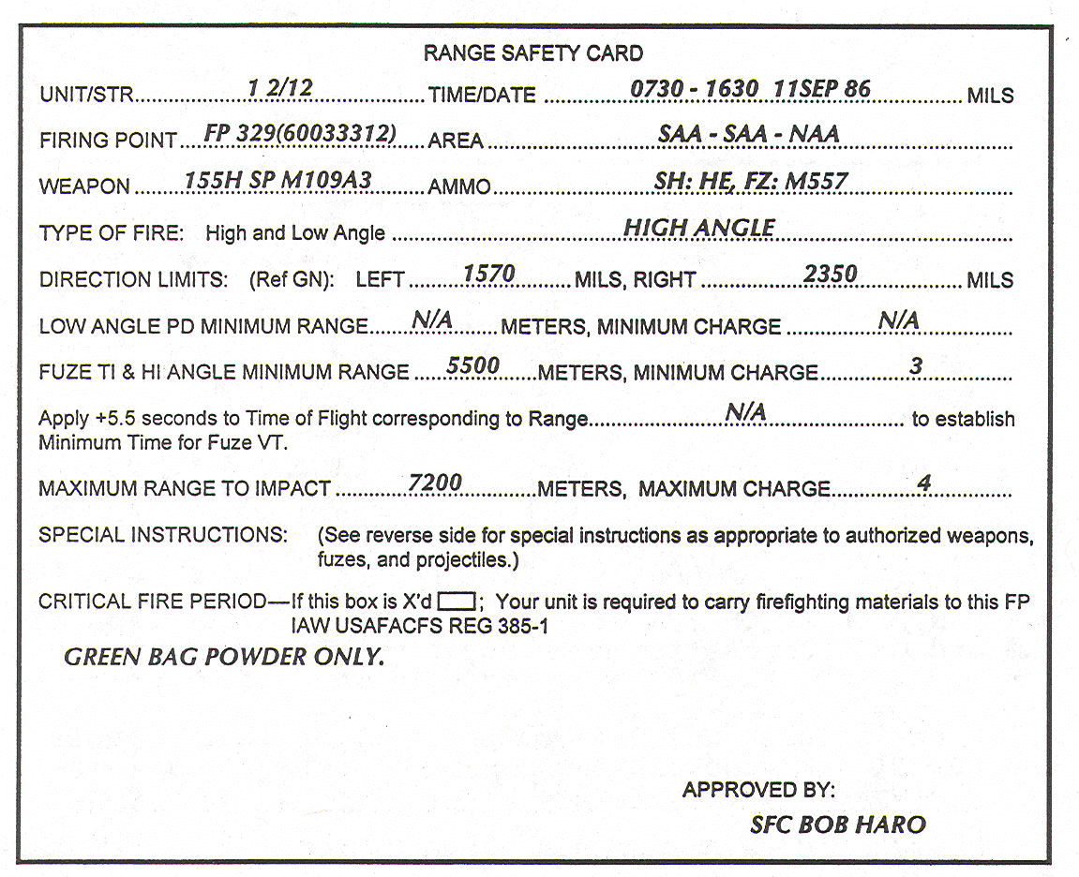

Figure 15. Range safety card for exercise 34.
/ / / / / / / / / / / / / / / / / / / / / / / / / / / / / / / / / / / / / / / / / / / / / / / / / / / / / / / / / /
ANSWER:
34. Your diagram should resemble the one below.

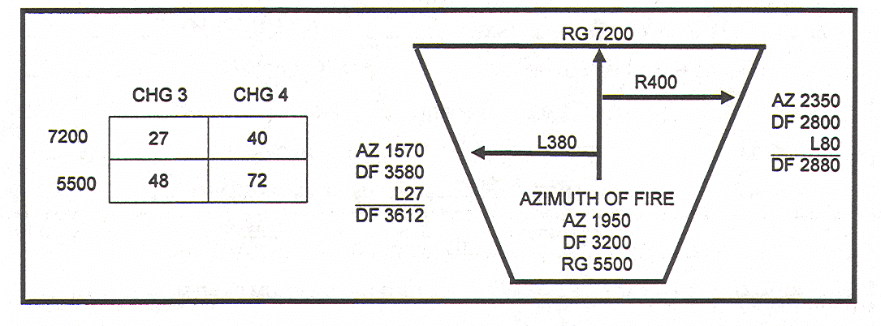

/ / / / / / / / / / / / / / / / / / / / / / / / / / / / / / / / / / / / / / / / / / / / / / / / / / / / / / / / / /
15. QUADRANT ELEVATION FOR HIGH-ANGLE FIRE. Computation of the minimum and maximum QEs for high-angle and low-angle fire is similar. However, the following exceptions must be noted:
a. Site for high angle is computed by using the angle of site and the l0-mil site factor from the GFT. (The 10-mil site factor is always negative.)
b. Maximum QE is computed for the minimum range, and minimum QE is computed for maximum range- -the reverse of the procedure for low-angle fire.

EXAMPLE: Study the example (Fig 16) of the maximum QE for minimum range, charges 3GB and 4GB, VI +49 meters.

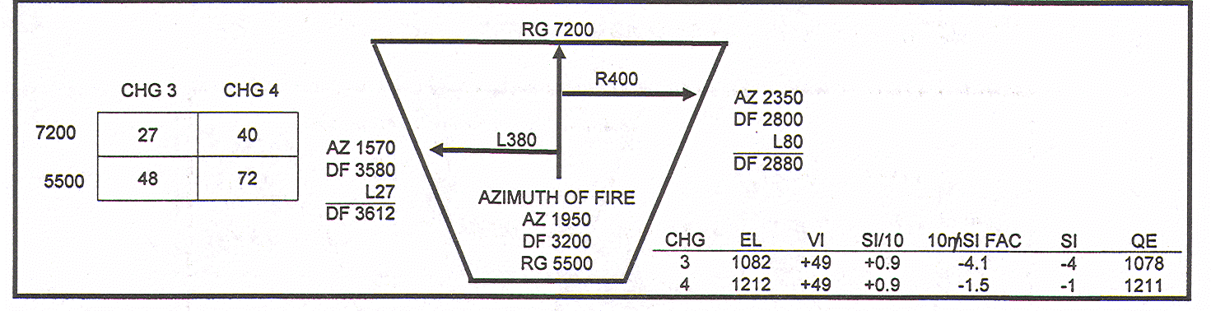

Figure 16. High-angle maximum QE.

Computation for charge 3GB Computation for charge 4GB
Angle of site (GST, +49/5.5) +9 Angle of site (GST,+49/5.5) +9
10-mil site factor (GFT) -4.1 10—mil site factor (OFT) -1.5
Site (0.9 x (-3.9)) -4 Site (0.9 x [-1.3]) -1
Elevation (GFT, 5500) 1082 Elevation (GFT, 5500) 1212
Maximum QE 1078 Maximum QE 1211
c. In high-angle fire, minimum settings for VT and time fuzes are not considered, and minimum QEs for maximum ranges and maximum QEs for minimum ranges are not considered for charges that cannot reach those ranges.
EXAMPLE:
Study the example in Figure 17 that explains computation of the minimum QE for maximum range, charge 4GB, vertical interval +32 meters.

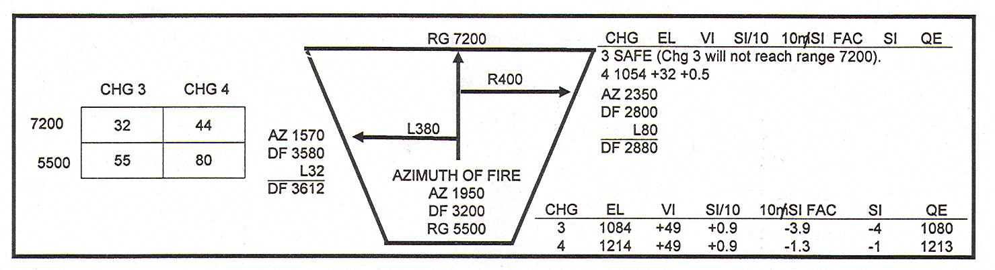
Figure 17. Safety diagram--high-angle minimum QE.
Computations: Chg 4GB, rg 7,200
si (+32/7) +5
l0-mil site factor -5.7
Site (0.5 x (-5.7) = -2.85, or -3) -3
Elevation 1040
QE 1037 PRACTICE EXERCISE:
35. Using the information from Figure 18, construct the basic diagram for high-angle fire and other safety data.
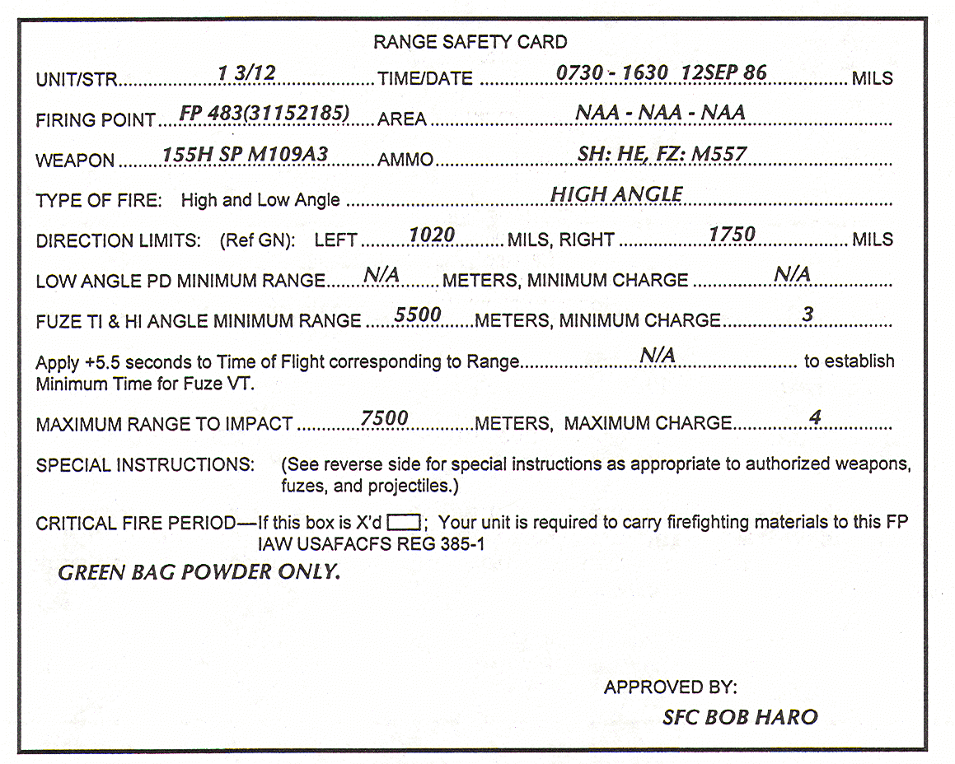

The following data have been determined by the safety officer:
Azimuth of fire 1390
Battery altitude 347
Max altitude at mm range 362
Min altitude at max range 348
Max altitude at max range 393
Mm altitude at max range 377
Common deflection 3200
Figure 18. Range safety card for exercise 35.

/ / / / / / / / / / / / / / / / / / / / / / / / / / / / / / / / / / / / / / / / / / / / / / / / / / / / / / / / / /

ANSWER:
35. Your diagram should resemble the one shown below.

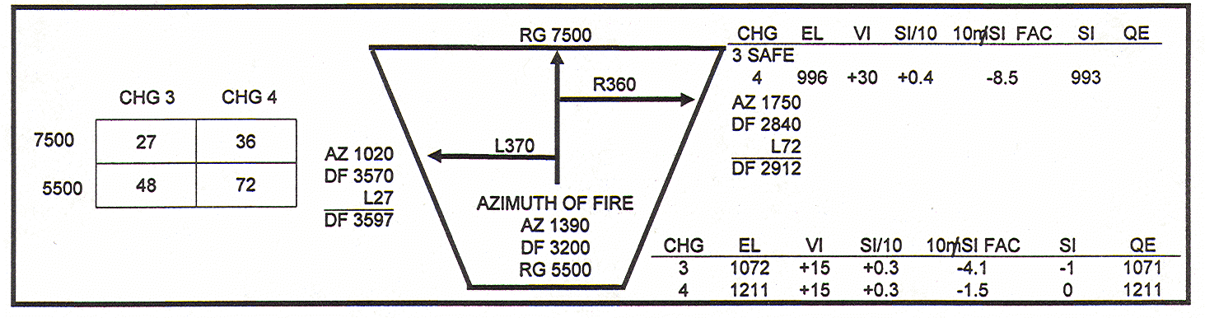

/ / / / / / / / / / / / / / / / / / / / / / / / / / / / / / / / / / / / / / / / / / / / / / / / / / / / / / / / / /

Review the lesson on high angle until you understand the computations.
16. SUMMARY. Safety computations are made to define the limits for artillery firing. There are specific procedures for the various shell fuzes combinations. A quick reference for safety computations is FC 6-50-20.

